Possible options:

RAG - create embeddings from the PDF file content and store it in a vector DB like chromadb, etc. You will use this DB and combine it with LLM. This will solve the purpose of using PDF data with LLM but not your goal of creating your own private LLM.

streamlit for frontend , ollama for LLM , FAISS or chroma DB for embedding , and an Vector DB , you can also add tools for usage based retrieval
Ollama Embeddings + Local Vector DB instance + RAG
chatbase.co
a
Yes, it's definitely possible. Instead of training a model from scratch, you can use a lightweight option like GPT4All or a llama-based model combined with retrieval-augmented generation. In simple terms, you'd extract vector embeddings from your PDFs (using a tool like FAISS) and let the model fetch the most relevant info when needed. This method keeps things efficient and lets you run everything locally on a small dataset.

Private GPT
Chatdocs

https://github.com/langchain-ai/rag-from-scratch

Terminologies to know:
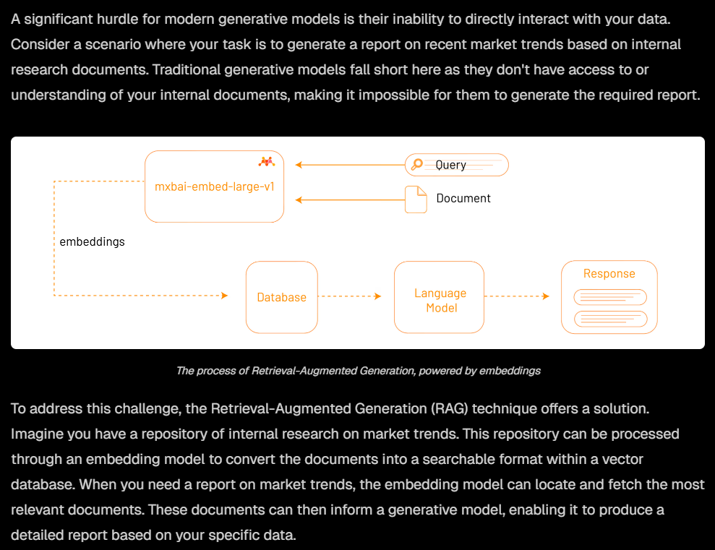
LangChain is an open-source orchestration framework that simplifies building applications powered by large language models (LLMs). Available in Python and JavaScript, it provides tools and components to connect LLMs with external data and other services, allowing developers to create complex, multi-step workflows for AI applications like chatbots, virtual assistants, and data analysis tools. LangChain offers a standardized interface for interacting with various LLMs, making it easier to build, test, and deploy powerful generative AI applications without having to reinvent fundamental infrastructure.

Ollama embedding refers to the process of converting text into numerical vectors using the Ollama platform, which allows for local execution of AI models. An "embedding" is a vector (a list of floating-point numbers) that captures the semantic meaning of the text, where similar texts have vectors that are closer together in space. Ollama provides a tool to run these embedding models and generate these vectors on your own system, enabling applications like enhanced search, recommendation systems, and chatbots.

How it Works
- 1. Local Model Execution:
Ollama allows you to download and run various embedding models (which are smaller, specialized versions of AI models) on your local machine.
- 2. Text to Vector Conversion:
You provide text to the model through an API, and it converts the text into a mathematical representation called an embedding.
- 3. Vector-Based Meaning:
These numerical vectors represent the "meaning" of the text, and the distance between two vectors can indicate how related the original texts are.
- 4. Integration with Applications:
These embeddings can be stored in a vector database and then used for tasks like:
  - Semantic Search: Finding information based on meaning rather than just keywords.

  - Recommendation Systems: Suggesting products or content similar to what a user has shown interest in.

  - Chatbots: Enabling more accurate and contextually relevant responses from virtual assistants.

Key Characteristics
- Local and Private:
Ollama's embedding feature runs models locally, providing privacy for your data.
- Open-Source:
Ollama is a free and open-source tool, giving you flexibility to use and integrate it.
- Model Variety:
Ollama supports a range of embedding models, allowing you to choose the best fit for your needs.
In essence, Ollama's embedding functionality gives you the power to create rich, context-aware numerical representations of your text data on your own machine, unlocking advanced capabilities for various AI applications.

A vector database in AI stores and manages data as high-dimensional mathematical vectors, or "embeddings," which are numerical representations of complex information like text, images, or audio, capturing their semantic meaning. These databases enable similarity search, finding conceptually similar data points rather than relying on exact matches, making them crucial for AI applications like recommendation systems, natural language processing, and powering Large Language Models (LLMs).

How They Work
- 1. Vectorization:
Machine learning models convert complex data (text, images, audio) into numerical arrays called vector embeddings.
- 2. Multi-dimensional Space:
These vectors are then stored in the database, where similar items are positioned close to each other, creating a "vector space".
- 3. Similarity Search:
The database uses specialized algorithms to perform similarity searches, quickly finding vectors (and thus, the original data) that are conceptually or contextually similar to a given query.

Bert-large Sized Models
- Bert-large is a standard large version of the BERT transformer model with 340 million parameters. It's used as a reference point for "large" transformer-based models in natural language processing.dataloop
- "Bert-large sized" means the new model has roughly equivalent scale, complexity, and potential capacity as BERT-large.

MTEB (Massive Text Embedding Benchmark)
- MTEB is a comprehensive evaluation framework—a collection of over 50 datasets and 8 major task types (classification, clustering, retrieval, semantic similarity, summarization, etc.).geeksforgeeks+2
- It measures how well embedding models (models that convert text into numerical vectors) generalize and perform across diverse domains and tasks.deepchecks
- Significance: Ranking high or SOTA on MTEB shows that a model is versatile, not just strong in one area, but in a variety of real-world use cases: search, clustering, cross-lingual tasks, etc.zilliz+1

No Overlap of the MTEB Data
- No overlap in training means MTEB datasets were not present or seen during the model's data collection or training phase.mixedbread
- This proves true generalization: high scores aren't due to memorizing test answers but because the model genuinely learns to handle new, diverse data and tasks well, even if unseen before.mixedbread

https://www.mixedbread.com/blog/mxbai-embed-large-v1

In embedded models, parameter size refers to the total number of trainable variables (weights) that the model uses to learn and represent knowledge. More specifically:
- Parameters are the weights and biases inside the neural network that the model adjusts during training to map input text into vector embeddings.
- The size (number) of parameters often correlates with the model’s capacity to capture complex language patterns and semantics—a larger parameter size usually means a more powerful but computationally expensive model.
- For example, BERT-large has about 340 million parameters, which defines its model scale and ability to represent language features.stackoverflow+1

Distinction from Embedding Dimension
- Parameter size is different from embedding dimension (which is the length of the output vector representing text).
- For instance, an embedding vector might be a fixed length like 768 or 3072 dimensions regardless of the input text length, but the underlying model has millions or billions of parameters controlling how those vectors get generated.google+2

Why Parameter Size Matters
- Larger parameter models tend to produce richer, more accurate embeddings that work better on complex tasks.
- However, bigger models require more computational resources and storage.
- Researchers try to balance parameter size with efficiency, sometimes using smaller models with smart techniques to approach the performance of larger ones.openai+2
In short, parameter size measures the complexity and capacity of the embedding model itself, which influences how well it can understand and represent text in vector space.stackoverflow+1
- https://stackoverflow.blog/2023/11/09/an-intuitive-introduction-to-text-embeddings/
- https://ai.google.dev/gemini-api/docs/embeddings
- https://cloud.google.com/vertex-ai/generative-ai/docs/embeddings/get-text-embeddings
- https://openai.com/index/new-embedding-models-and-api-updates/
- https://docs.aws.amazon.com/bedrock/latest/userguide/titan-embedding-models.html
- https://community.openai.com/t/understanding-text-embedding-ada-002-vector-length-of-1536/464737
- https://docs.anthropic.com/en/docs/build-with-claude/embeddings
- https://huggingface.co/spaces/hesamation/primer-llm-embedding

Here is the distinction between parameters and vectors (and their sizes) in embedding models explained clearly:

Parameters of a Model
- Parameters are the internal trainable weights of the embedding model itself.
- They define the complexity and capacity of the neural network used to convert input text into vector embeddings.
- The parameter size is the total number of these weights (e.g., millions or billions) inside the model.
- A larger parameter size generally means the model can learn more detailed and nuanced representations but requires more computation and memory.stackoverflow+2

Vectors (Embedding Vectors)
- A vector or embedding vector is the output of the model after processing input text.
- It is a fixed-length array of numbers (e.g., length 768, 1536, or 3072) that represents the semantic meaning of that input.
- The vector size (dimension) refers to how many numbers/components are in this output embedding.
- This vector is what is used for downstream tasks like similarity comparison, clustering, or search.snaplogic+2

Key Differences
Aspect | Parameters (Model Size) | Vectors (Embedding Size)
What it is | Internal trainable weights in the neural network | Output numerical representation of input text
Typical scale | Millions to billions of parameters | Usually hundreds to thousands of vector dimensions
Purpose | Captures how the model transforms text into vectors | Captures semantic features of an individual sentence/text
Size implication | Larger means more powerful model, more computation | Larger means richer representation, more storage needed
Changes during use | Fixed after training | Generated fresh for each input text

Example
- A BERT-large model might have 340 million parameters (the model size).
- It outputs embeddings as vectors of length 1024 or 768, which encode sentences or documents into mathematical representations that downstream tasks use for similarity or ranking.ibm+2
In summary, parameters are the model’s internal complexity, while vectors are the model’s output representation of specific input data. The size of each reflects different things: one the model’s capability, the other the embedding granularity.In an embedding model, parameters and vectors refer to different concepts and their sizes mean different things:stackoverflow+2
- Parameters are the internal trainable weights of the embedding model itself. The parameter size indicates the total number of these weights, typically in millions or billions. This size reflects the model's complexity and its capacity to learn and represent language patterns. Larger parameter sizes often mean more powerful models but also higher computational and memory costs.
- Vectors (or embedding vectors) are the output representations the model produces for input text. Each input (like a sentence or document) is converted into a fixed-length numerical vector. The vector size (dimension) is the length of this output array and usually ranges from a few hundred to a few thousand numbers. Larger vectors can capture richer semantic details but require more storage and processing.
To summarize:
- Parameter size measures the model’s internal complexity and learning capacity.
- Vector size is the length of the semantic representation output for each input example.
They serve different roles: parameters shape how embeddings are created, while vectors represent actual data points in a continuous space for downstream tasks like similarity or clustering.google+3
- https://community.openai.com/t/embeddings-performance-difference-between-small-vs-large-at-1536-dimensions/618069
- https://stackoverflow.blog/2023/11/09/an-intuitive-introduction-to-text-embeddings/
- https://community.openai.com/t/understanding-text-embedding-ada-002-vector-length-of-1536/464737
- https://huggingface.co/spaces/hesamation/primer-llm-embedding
- https://community.snaplogic.com/blog/sl-tech-blog/embeddings-and-vector-databases/39516
- https://www.ibm.com/think/topics/vector-embedding
- https://www.datarobot.com/blog/choosing-the-right-vector-embedding-model-for-your-generative-ai-use-case/
- https://www.mongodb.com/developer/products/atlas/choose-embedding-model-rag/
- https://ai.google.dev/gemini-api/docs/embeddings

This example code illustrates building a Retrieval-Augmented Generation (RAG) application that combines text embeddings for retrieval with a generation model for answering queries. It uses the mxbai-embed-large model for embedding and Llama 2 for generation via the Ollama and ChromaDB libraries.

Step-by-Step Code Explanation

Step 1: Generate Embeddings
python
import ollama
import chromadb

- Imports the Ollama library to access embedding and generation models.
- Imports ChromaDB, a vector database used to store and query embeddings.
python
documents = [
"Llamas are members of the camelid family meaning they're pretty closely related to vicuñas and camels",
"Llamas were first domesticated and used as pack animals 4,000 to 5,000 years ago in the Peruvian highlands",
"Llamas can grow as much as 6 feet tall though the average llama between 5 feet 6 inches and 5 feet 9 inches tall",
"Llamas weigh between 280 and 450 pounds and can carry 25 to 30 percent of their body weight",
"Llamas are vegetarians and have very efficient digestive systems",
"Llamas live to be about 20 years old, though some only live for 15 years and others live to be 30 years old",
]

- A list of documents (facts about llamas) sets the knowledge base.
python
client = chromadb.Client()
collection = client.create_collection(name="docs")

- Creates a client connection to the ChromaDB vector database.
- Creates a new collection named "docs" to store embeddings and documents.
python
for i, d in enumerate(documents):
response = ollama.embed(model="mxbai-embed-large", input=d)
embeddings = response["embeddings"]
collection.add(
ids=[str(i)],
embeddings=embeddings,
documents=[d]
)

- Loops through each document:
  - Calls Ollama's mxbai-embed-large embedding model to convert the document text d into its numeric embedding vector.
  - Stores the document’s embedding vector and text into the ChromaDB collection, associating it with an ID (stringified index).
- This sets up a searchable vector database representing the documents semantically.

Step 2: Retrieve Relevant Documents
python
input = "What animals are llamas related to?"

- This is the user's query or prompt wanting information about llamas' related animals.
python
response = ollama.embed(
model="mxbai-embed-large",
input=prompt
)

- Generates an embedding vector for the query using the same embedding model, converting the question into a vector space representation reflecting its meaning.
python
results = collection.query(
query_embeddings=[response["embeddings"]],
n_results=1
)
data = results['documents'][0][0]

- Uses the query embedding to search the ChromaDB collection.
- Retrieves the most relevant document (closest vector match) to the query.
- Extracts the text of this document—the closest match to the question.

Step 3: Generate the Final Answer
python
output = ollama.generate(
model="llama2",
prompt=f"Using this data: {data}. Respond to this prompt: {input}"
)

- Calls Ollama's Llama 2 generative language model.
- Provides a prompt combining:
  - The retrieved document's factual data (data).
  - The original question (input).
- Llama 2 uses the retrieved info as context and generates a natural language answer tailored to the input question.
python
print(output['response'])

- Prints the text response generated by Llama 2.

What the Model Does and How
- mxbai-embed-large converts both the documents and user queries into vector embeddings capturing semantic meaning.
- These embeddings enable semantic similarity search to find the document most relevant to the user’s question inside the vector database.
- The retrieved document provides factual, relevant context.
- Llama 2 then generates a fluent, contextual answer using the retrieved context, rather than guessing or hallucinating without grounding.
- This combination — retrieving grounded information and then generating an answer — is the core of the Retrieval-Augmented Generation (RAG) paradigm.
- The system can handle open-ended questions by dynamically fetching relevant knowledge first, then producing precise, informed responses.

Summary
- Embeddings turn text into meaning-rich vectors for similarity search.
- The vector database stores these vectors for quick retrieval.
- Query embeddings find the closest fact or info.
- The generative model creates natural answers grounded in retrieved facts.
- This method improves factual accuracy and relevance in AI-generated answers using the mxbai-embed-large model and Llama 2 together.

Quantization for a model is a technique used to reduce the size and computational requirements of machine learning models by converting their internal numerical values (weights and activations) from high-precision formats like 32-bit floating points to lower-precision formats such as 8-bit integers.

What Quantization Means Specifically:
- It converts numbers stored with many bits (e.g., 32 bits per value) into fewer bits (e.g., 8 bits per value).
- This reduced precision lowers the memory needed to store the model and speeds up computation because operations on smaller numbers are faster and require less energy.
- Quantization makes it possible to run large models on less powerful, resource-constrained devices like smartphones, IoT devices, and edge hardware.

Benefits of Quantization:
- Smaller model size: The model takes up less storage.
- Faster inference: Predictions happen more quickly due to simpler math operations.
- Lower power consumption: Important for battery-operated or energy-limited devices.

Trade-offs:
- Quantization can slightly reduce model accuracy due to the loss of some numerical precision, known as quantization error.
- However, modern quantization techniques minimize this loss to maintain strong model performance.
In short, quantization compresses AI models by using fewer bits to represent their internals, making them lighter and faster to run, especially on limited hardware, while aiming to keep accuracy high.cloudflare+5
- https://www.cloudflare.com/learning/ai/what-is-quantization/
- https://huggingface.co/docs/optimum/en/concept_guides/quantization
- https://www.ibm.com/think/topics/quantization
- https://www.geeksforgeeks.org/deep-learning/quantization-in-deep-learning/
- https://www.digitalocean.com/community/tutorials/model-quantization-large-language-models
- https://www.baseten.co/blog/introduction-to-quantizing-ml-models/
- https://www.scaleway.com/en/blog/quantization-machine-learning-efficiency-part1/
- https://stackoverflow.blog/2023/08/23/fitting-ai-models-in-your-pocket-with-quantization/

